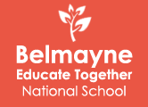

COVID-19 Response Plan & Policy for the Safe and Sustainable Reopening of Belmayne ETNS
Reviewed February 2021

2021
Contents
COVID-19 Policy Statement 3
1. Introduction 4
2. What is a COVID-19 Response Plan? 4
3. School COVID-19 Policy 5
4. Planning and Preparing for Return to School 5
4.1. Induction Training 6
4.2. Procedure for Returning to Work / School (RTW/S) 6
4.3. Lead Worker Representative 7
4.4. Signage 9
4.5. Making Changes to School Layout 9
4.6. Health and Safety Risk Assessment 9
4.7. Access to School and Contact Log 9
5. Control Measures - To prevent Introduction and Spread of COVID-19 in Schools 10
5.1. Know the Symptoms of COVID-19 11
5.2. Respiratory Hygiene 11
5.3. Hand Hygiene 11
5.4. Physical Distancing 12
5.4.1. Increasing separation 13
5.4.2. Decreasing interaction 13
5.4.3. Additional measures to decrease interaction include: 14
5.5. Physical Distancing outside of the classroom and within the school 14
5.5.1. School drop off/collection 14
5.5.2. Staff 15
5.5.3. Corridors and Stairwells 15
5.5.4. Yard/Supervision 15
5.6. Use of PPE in Schools 16
5.6.1. Masks 16
5.6.2. Gloves 16
6. Impact of COVID-19 on certain school activities 16
6.1. Non-curricular/Afterschool Activities/Additional Curricular Activities 16
6.2. Student Council 16
6.3. Shared Equipment 17
6.3.1 Toys 17
6.3.2. School iPads 17
6.3.3. Musical Equipment/Instruments 17
6.3.4. Library Policy and Class Books 18
6.3.5. Shared Sports Equipment 18
7. Hygiene and Cleaning in Schools 18
7.1. General Guidelines 18
7.2. Cleaning/Disinfecting rooms where a pupil/staff member with suspected COVID-19 was present 18
8. Dealing with a Suspected Case of COVID-19 19
8.1 If a pupil displays symptoms of COVID-19 while at school the following are the procedures to be implemented: 19
8.2 If a staff member displays symptoms of COVID-19 while at school the following are the procedures to be implemented: 20
9. Special Educational Needs 20
10. Staff Duties 21
10. COVID-19 related Absence Management 22
11. Employee Assistance and Wellbeing Programme 22
12. Ratification and Review 23
13. Appendices 24
13.1. Appendix 1 – Hand Hygiene and General Cleaning 24
13.2. Appendix 2 – Suggested Classroom Layouts 28
13.3. Appendix 3 – Layout of School Building 29
13.4. Appendix 4 – Yard Time and Supervision 31
13.5. Appendix 5 – Morning Time Procedures (Coming to School) 36
13.6. Appendix 6 – End of Day Procedures (Home Time) 40
13.7. Appendix 7 – Completed Risk Assessment 43

COVID-19 Policy Statement
Belmayne Educate Together National School is committed to providing a safe and healthy workplace for all our staff and a safe learning environment for all our pupils. To ensure that, we have developed the following COVID-19 Response Plan. The BOM and all school staff are responsible for the implementation of this plan and a combined effort will help contain the spread of the virus. We will:

- continue to monitor our COVID-19 response and amend this plan in consultation with our staff
- provide up to date information to our staff and pupils on the Public Health advice issued by the HSE and Gov.ie
- display information on the signs and symptoms of COVID-19 and correct handwashing techniques
- agree with staff, a worker representative who is easily identifiable to carry out the role outlined in this plan
- inform all staff and pupils of essential hygiene and respiratory etiquette and physical distancing requirements
- adapt the school to facilitate physical distancing as appropriate in line with the guidance and direction of the Department of Education
- keep a contact log to help with contact tracing
- ensure staff engage with the induction / familiarisation briefing provided by the Department of Education
- implement the agreed procedures to be followed in the event of someone showing symptoms of COVID-19 while at school
- provide instructions for staff and pupils to follow if they develop signs and symptoms of COVID-19 during school time
- implement cleaning in line with Department of Education advice

All school staff will be consulted on an ongoing basis and feedback is encouraged on any concerns, issues or suggestions.

This can be done through the Lead Worker Representative(s), who will be supported in line with the agreement between the Department and education partners.

Signed: Carol Norton (Chairperson of BOM) Date: 26th February 2021
Signed: Sinead O’Meara (Principal) Date: 26th February 2021

Introduction
The Minister for Education has published “The Roadmap for the Full Return to School” on the 27th July. It sets out what the operation of schools will look like and the range of supports which will be available in a COVID-19 context.
It has been developed in line with public health advice issued by the Health Protection Surveillance Centre (HPSC) and in compliance with the “Return to Work Safely Protocols” developed by the Department of Business, Enterprise and Innovation and the Department of Health with guidance documents provided by the Health and Safety Authority (HSA). Belmayne ETNS is required to have a COVID-19 Response Plan. In addition to being a place of learning, Belmayne ETNS is also a place of work. This document sets out the information that we, as a school, need to implement a School COVID-19 Response Plan, including a COVID-19 policy, lead worker representative and process to deal with a suspected case of COVID-19.
The purpose of this document is to provide clear and helpful guidance for the safe operation through the prevention, early detection and control of COVID-19 in Belmayne ETNS. It provides key messages to minimise the risk of COVID-19 for staff, pupils, families and the wider community while recognising the importance of education for the health and wellbeing of pupils and society as a whole.
This document focuses on the practical steps which will be taken in Belmayne ETNS to minimise the risk of the introduction of infection into our school while recognising that no interpersonal activity is without risk of transmission of infection at any time. The documentation and templates in this booklet are supported by the public health advice provided by the Health Protection Surveillance Centre (HPSC) for the safe reopening of schools and educational facilities.
One of the key challenges is to balance the need for a practical and sensible level of caution with the need to provide a supportive environment for teaching and learning. This document identifies the steps we will take to do everything practical to avoid the introduction of COVID-19 into the school and the steps that can be taken to reduce the likelihood of the spread within the school itself.

What is a COVID-19 Response Plan?
A COVID-19 Response Plan is designed to support the staff and Board of Management in putting measures in place that aim to prevent the spread of COVID-19 in the school environment.
The COVID-19 Response Plan details the policies and practices necessary for Belmayne ETNS to meet the Government’s ‘Return to Work Safely Protocol’, the Department of Education plan for school reopening and to prevent the introduction and spread of COVID-19 in the school environment.
It is important that the resumption of school-based teaching and learning and the reopening of school facilities complies with the public health advice and guidance documents prepared by the Department. Doing so minimises the risk to pupils, staff and others. The response plan supports the sustainable reopening of school where the overriding objective is to protect the health of staff and pupils while promoting the educational and development needs of the pupils in the school. The COVID-19 response plan is a living document and will be updated in line with the public health advice as appropriate for primary and special schools.
In line with the Return to Work Safely Protocol, the key to a safe and sustainable return to work, and reopening of schools requires strong communication and a shared collaborative approach between the BOM, staff, pupils and parents.
The assistance and cooperation of all staff, pupils, parents, contractors and visitors is critical to the success of the plan.
Every effort is made to ensure the accuracy of the information provided in this document. However, should errors or omissions be identified, please notify us so that appropriate measures can be taken to rectify same.

School COVID-19 Policy
A COVID-19 policy outlines the commitment of the school to implement the plan and help prevent the spread of the virus. The policy will be signed and dated by the chairperson and principal of the BOM and brought to the attention of the staff, pupils, parents and others. Schools must have a COVID-19 policy in place prior to the reopening of schools for the 2020/21 school year. The COVID-19 Policy Statement can be found at the beginning of this document.

Planning and Preparing for Return to School
The Board of Management of Belmayne ETNS, aims to facilitate the resumption of school based teaching and learning and the return to the workplace of staff. The return to the workplace must be done safely and in strict adherence to the public health advice and any guidance issued by the Department of Education.
Details for the safe reopening of the school facility and the applicable controls are outlined in this document.
Before reopening schools for the 2020/21 school year each school will need to have processes in place to include the following:
- Arrangements to keep up to date with public health advice, changes to any Government plans for the safe reopening of society and Department of Education updates;
- Arrangements to pass on this information in a timely manner to staff, pupils, parents and others as required;
- Ensured that staff have reviewed the training materials provided by the Department of Education (details at Section 4.1);
- Provided staff with access to the Return to Work (RTW) form (details at Section 4.2);
- Identified a Lead Worker representative (details at Section 4.3);
- Displayed posters and other signage to prevent introduction and spread of COVID-19 (details at Section 4.4);
- Made the necessary changes to the school or classroom layout if necessary to support the redesign of classrooms to support physical distancing (details at Section 4.5);
- Removed unnecessary clutter to facilitate ongoing cleaning of the school taking into account the importance of having educational materials to create a stimulating learning environment;
- Updated the health and safety risk assessment (details at Section 4.6);
- Made necessary arrangements to limit access to the school to necessary visitors and maintain records of contacts to the school (details at 4.7);
- Reviewed the school buildings to check the following:
- Does the water system need flushing at outlets following low usage to prevent Legionella disease;
- Has school equipment and mechanical ventilation been checked for signs of deterioration or damage before being used again;
- Have bin collections and other essential services resumed.

4.1. Induction Training
All staff will undertake and complete COVID-19 Induction Training prior to returning to the school building. The aim of such training is to ensure that staff have full knowledge and understanding of the following:
- Latest up to-date advice and guidance on public health;
- COVID-19 symptoms;
- What to do if a staff member or pupil develops symptoms of COVID-19 while at school;
- Outline of the COVID-19 response plan.
Staff will be kept fully informed of the control measures in place in the school and their duties and responsibilities in preventing the spread of COVID-19 and will be updated with any changes to the control measures or guidance available from the public health authorities.
If a staff member is unsure about any aspect of the COVID-19 Response Plan, the associated control measures, or his/her duties, he/she should immediately seek guidance from the Principal, who is supported in this role by the BOM.

4.2. Procedure for Returning to Work / School (RTW/S)
In order to return to the workplace, staff and parents of pupils must complete a Return to Work / School (RTW/S) form, which is available online.
The RTW form should be completed by staff and returned 3 days before returning to work. The RTS form will be sent to all parents on Friday 26th February 2021. Parents must complete one form for each child returning to school before 12pm on 28th February.
The principal provided details of the Induction Training (provided to staff on the 18th of August) for completion by staff and details of any additional health and safety measures in place in the school to facilitate the staff member’s return to the school facility. These measure were discussed at our staff meeting prior to returning on March 1st. An updated Covid-19 Response Plan and Risk Assessment has been made available to all staff. All staff are required to familiarize themselves with the updated information in line with Appendix 3 Summary of additions to COVID-19 Response Plans required by ‘Work Safely Protocol’.
There are some school staff who may be unable to return to school. Current public health guidelines have identified these people as being in groups who are defined as being at very high risk. This will be updated in line with public health advice.
People at very high risk (extremely vulnerable):
The list of people in very high risk groups include people who:
- are over 70 years of age - even if fit and well
- have had an organ transplant
- are undergoing active chemotherapy for cancer
- are having radical radiotherapy for lung cancer
- have cancers of the blood or bone marrow such as leukaemia, lymphoma or myeloma who are at any stage of treatment
- are having immunotherapy or other continuing antibody treatments for cancer
- are having other targeted cancer treatments which can affect the immune system, such as protein kinase inhibitors or PARP inhibitors
- have had bone marrow or stem cell transplants in the last 6 months, or who are still taking immunosuppression drugs
- have severe respiratory conditions including cystic fibrosis, severe asthma, pulmonary fibrosis, lung fibrosis, interstitial lung disease and severe COPD
- have a condition that means they have a very high risk of getting infections (such as SCID, homozygous sickle cell)
- are taking medicine that makes you much more likely to get infections (such as high doses of steroids or immunosuppression therapies)
- have a serious heart condition and are pregnant
Although not specifically listed as High Risk. Pregnant members of staff have been advised to work from home as per current government return to work guidelines.
The advice for this group is available from the HSE. Details of the arrangements that will apply for these staff, which will be in accordance with those applying for the public service generally, will be updated by the Department of Education following consultation with management bodies and unions and a circular will issue to all schools.

4.3. Lead Worker Representative
The Protocol provides for the appointment of a Lead Worker Representative (LWR) in each workplace. The LWR will work in collaboration with the employer to assist in the implementation of measures to prevent the spread of COVID-19 and monitor adherence to those measures and to be involved in communicating the health advice around COVID-19 in the workplace.
This section sets out how the provisions will operate in Belmayne ETNS. The process for appointment of the lead worker representative in schools has been agreed centrally between the Department of Education and the education partners.
Responsibility for the development and implementation of the COVID-19 Response Plan and the associated control measures lies primarily with the Board of Management/ Education and school management.
Strong communication and a shared collaborative approach is key to protecting against the spread of COVID-19 in schools, and looking after the health, safety and wellbeing of staff and students. Adherence to the Return to Work Protocol will only be achieved if everyone has a shared responsibility in implementing the measures contained within the Protocol in their place of work.
If a staff member has any concerns or observations in relation to the COVID-19 Response Plan, control measures or the adherence to such measures by staff, pupils or others he/she should contact the lead worker(s) who will engage with the principal/BOM.
Role of the Lead Worker Representative (LWR)
In summary, the role of the LWR is to:

- Represent all staff in the workplace regardless of role, and be aware of specific issues that may arise in respect of different staff cohorts;
- Work collaboratively with school management to ensure, so far as is reasonably practicable, the safety, health and welfare of employees in relation to COVID-19;
- Keep up to date with the latest COVID-19 public health advice;
- In conjunction with school management, promote good hygiene practices such as washing hands regularly and maintaining good respiratory etiquette along with maintaining social distancing in accordance with public health advice;
- Assist school management with the implementation of measures to suppress COVID-19 in the workplace in line with the Return to Work Safely Protocol and current public health advice;
- In conjunction with school management, monitor adherence to measures put in place to prevent the spread of COVID-19;
- Conduct regular reviews of safety measures;
- Report any issues of concern immediately to school management and keep records of such issues and actions taken to rectify them;
- Consult with the school management on the school’s COVID-19 Response Plan in the event of someone developing COVID-19 while in school including the location of an isolation area and a safe route to that area;
- Following any incident, assess with the school management any follow up action that is required;
- Consult with colleagues on matters relating to COVID-19 in the workplace;
- Make representations to school management on behalf of their colleagues on matters relating to COVID-19 in the workplace.

Every school will appoint one Lead Worker Representative.

As Belmayne ETNS has 30 or more staff, an Assistant Lead Worker Representative will be appointed in addition to the LWR. The role of the Assistant LWR will be to:

- assist the LWR in their duties as set out above; and
- deputise as LWR where the LWR is absent

Name(s) of lead worker representatives: | Contact details:
TBD - Aoife McDonnell (LWR) | Available to Staff
TBD - Elaine Moran (Assistant LWR) | Available to Staff

All staff, pupils, parents, contractors and visitors have a responsibility both as individuals and collectively to have due regard for their own health and safety and that of others and to assist with the implementation of the COVID-19 Response Plan and associated control measures.

4.4. Signage
Schools will be required to display signage outlining the signs and symptoms of COVID-19 and to support good hand and respiratory hygiene. The Department will provide printed posters to schools, with age appropriate key health messages – hand washing, sneeze and cough etiquette etc. Schools can then arrange to display the posters in prominent areas such as offices, corridors, staffroom area, classrooms and toilets.

4.5. Making Changes to School Layout
Maintaining physical distancing in the school environment is recommended as one of the key control measures to minimize the risk of the introduction and spread of COVID-19. Further information on how physical distancing can be used in the school environment is found at Section 5.4 below.
Belmayne ETNS will reconfigure classrooms and other areas as necessary to support physical distancing in line with the guidance in advance of school reopening.

4.6. Health and Safety Risk Assessment
COVID-19 represents a hazard in the context of health and safety in the school environment. A template risk assessment to identify the control measures required to mitigate the risk of COVID-19 in school settings has been completed and is attached at Appendix 2.
We will review our existing risk assessments to consider any new risks that arise due to the school’s COVID-19 Response Plan. Any changes to the school’s current risk assessments will also be documented and incorporated into the school safety statement. The Risk Assessments have been reviewed in preparation for our return to work on March 1st 2021.
First Aid/Emergency Procedure
The standard First Aid/emergency procedure shall continue to apply in Belmayne ETNS. In an emergency or in case of a serious incident, schools should call for an ambulance or the fire brigade on 112/999 giving details of location and type of medical incident.

4.7. Access to School and Contact Log
Access to the school building will be in line with agreed school procedures.
Arrangements for necessary visitors such as contractors and parents will be restricted to essential purposes and limited to those who have obtained prior approval from the principal.
The prompt identification and isolation of potentially infectious individuals is a crucial step in restricting the spread of the virus and protecting the health and safety of the individuals themselves and other staff, contractors and visitors at the workplace. A detailed electronic sign in/sign out log of those entering the school facilities will be maintained. We will also maintain a log of staff and pupil contacts.

Control Measures - To prevent Introduction and Spread of COVID-19 in Schools
One of the key messages to manage the risks of COVID-19 is to do everything practical to avoid the introduction of COVID-19 into the school. If infection is not introduced it cannot be spread. The risk of spreading the infection once introduced exists in all interpersonal interactions; student-student, teacher-teacher and teacher-student and must be managed in all settings.
A range of essential control measures have been implemented to reduce the risk of the spread of COVID-19 virus and to protect the safety, health and welfare of staff, pupils, parents and visitors as far as possible within the school. The control measures shall continue to be reviewed and updated as required on an ongoing basis.
It is critical that staff, pupils, parents and visitors are aware of, and adhere to, the control measures outlined and that they fully cooperate with all health and safety requirements.
Staff should note that they have a legal obligation under Section 13 of the Safety, Health and Welfare at Work Act 2005 to comply with health and safety requirements and to take reasonable care for the health and safety of themselves, their colleagues and other parties within the workplace.
How to Minimise the Risk of Introduction of COVID-19 into Schools:
Promote awareness of COVID-19 symptoms (details at Section 5.1);
- Advise staff and pupils that have symptoms not to attend school, to phone their doctor and to follow HSE guidance on self-isolation;
- Advise staff and pupils not to return to or attend school in the event of the following:
- if they are identified by the HSE as a close contact of a confirmed case of COVID-19
- if they live with someone who has symptoms of the virus
- If they have travelled outside of Ireland; in such instances staff are advised to consult and follow latest Government advice in relation to foreign travel.
- Advise staff and pupils to cooperate with any public health officials and the school for contact tracing purposes and follow any public health advice in the event of a case or outbreak in the school;
- Advise staff and pupils that develop symptoms at school to bring this to the attention of the Principal promptly;
- Ensure that staff and pupils know the protocol for managing a suspected case of COVID-19 in school (details at Section 8);
- Everyone entering the school building needs to perform hand hygiene with a hand sanitiser;
- Visitors to the school during the day should be by prior arrangement and should be received at a specific contact point;
- Physical distancing (of 2m) should be maintained between staff and visitors where possible.
Ventilation
The Department has published guidance setting out the practical steps for good ventilation in accordance with public health advice ‘Practical Steps for the Deployment of Good Ventilation Practices in Schools’ The guidance sets out an overall approach for schools that windows should be open as fully as possible when classrooms are not in use (e.g. during break-times or lunch-times (assuming not in use) and also at the end of each school day) and partially open when classrooms are in use. The guidance provides that good ventilation can be achieved in classrooms without causing discomfort, particularly during cold weather.

5.1. Know the Symptoms of COVID-19
In order to prevent the spread of COVID-19 it is important to know and recognise the symptoms. They are:
- High temperature
- Cough
- Shortness of breath or breathing difficulties
- Loss of smell, of taste or distortion of taste

5.2. Respiratory Hygiene
Make sure you, and the people around you, follow good respiratory hygiene. This means covering your mouth and nose with a tissue or your bent elbow when you cough or sneeze. Then dispose of the used tissue immediately and safely into a nearby covered bin (if available).
By following good respiratory hygiene, you protect the people around you from viruses such as cold, flu and COVID-19.

5.3. Hand Hygiene
Staff and pupils should understand why hand hygiene is important as well as when and how to wash their hands. We will promote good hygiene and display posters throughout the schools on how to wash your hands. Follow the HSE guidelines on handwashing:
https://www2.hse.ie/wellbeing/how-to-wash-your-hands.html
Hand hygiene can be achieved by hand washing or use of a hand sanitiser (when hands look clean).
Use of hand hygiene facilities including wash hand basins will be managed so as to avoid congregation of people waiting to use wash hand basins and hand sanitisers.
Hand washing facilities (with warm water, liquid soap and paper towels) are available in each classroom (4 sinks) for after activities that are likely to soil hands, for example playing outside or certain sporting activities as hand sanitiser does not work on dirty hands.
Hand sanitiser dispensers will be deployed at exit and entry points of schools and classrooms and care will be taken to clean up any hand sanitiser spills to prevent risks of falls.
Hand washing facilities will be maintained in good condition and supplies of soap and towels will be topped up regularly to encourage everyone to use them.
Posters displaying hand washing techniques and promoting hand washing will be placed on walls adjacent to washing facilities.
Hand sanitiser is suitable for use for hand hygiene when hands are not visibly soiled (look clean).
Frequency of Hand Hygiene
Pupils and staff should perform hand hygiene:
- Before leaving home
- On arrival at school;
- Before eating or drinking;
- After using the toilet;
- After playing outdoors;
- When their hands are physically dirty;
- When they cough or sneeze.
- Before and and after wearing gloves
- Before and after being on public transport
- After touching potentially contaminated surfaces
- If in contact with someone displaying any COVID-19 symptoms
- After using any shared resources - equipment, toys or books
- When entering and exiting vehicles
- When entering and exiting school building

The Department has arranged for a drawdown framework to be established to enable schools to purchase hand-sanitisers and any other necessary PPE supplies for use in the school. The Department will provide funding for the costs associated with hand sanitising and PPE requirements in schools. This funding will be available in advance of school reopening at the end of August. More information on hand hygiene and general cleaning can be found in Appendix 3.

5.4. Physical Distancing
Physical distancing will be usefully applied in Belmayne ETNS, allowing for some flexibility when needed. It will be applied in a practical way to recognise that the learning environment cannot be dominated by a potentially counterproductive focus on this issue. Physical distancing will look different across the various ages and stages of learning. Care will be taken to avoid generating tension or potential conflict and some flexibility in the implementation of measures may be required at times. Suggested classroom layouts can be found in Appendix 4.
It is also recognised that it is not always possible for staff to maintain physical distance from pupils and it is not appropriate that they would always be expected to do so where this could have a detrimental impact on the pupil i.e. if a child sustains an injury and requires first aid.
However, where possible staff should maintain a minimum of 1m distance and where possible 2m. They should also take measures to avoid close contact at face to face level such as remaining standing rather than sitting beside/crouching down.
Physical distancing falls into two categories:
- Increasing separation
- Decreasing interaction

5.4.1. Increasing separation
The guidance documents provided by the Department of Education on optimal school layout and referenced at Section 4.5 above will be used to increase separation to the greatest degree possible
To maintain physical distancing in the classroom, we will:
- Reconfigure class spaces to maximise physical distancing (Appendix 4)
- Utilise and reconfigure all available space in the school in order to maximise physical distancing (Appendix 5)
To support primary schools in the implementation of physical distancing in the classroom, the Department has developed a suite of illustrative classroom layouts of potential options which are in accordance with the public health advice, and assumes

- Room is clear of any unnecessary furniture/shelves etc. on the walls
- A variety of classroom sizes.
Funding will be provided under the enhanced minor works grant to facilitate this classroom re-configuration works. This funding will be provided to schools by mid-August.
The teacher’s desk should be at least 1m and where possible 2m away from pupil desks.

5.4.2. Decreasing interaction
A common-sense approach is required in decreasing interaction and recognising the limits to which this can be achieved between pupils.
Achieving a 1 metre distance between pupils or pods in the first four years (junior infants to second class) of primary school, is not a pre-requisite to reopening the school for all pupils.
Where possible Pods will be allocated consistently to the same staff and children rather than having spaces which are shared.
The risk of infection may be reduced by structuring pupils and their teachers into Class Bubbles (i.e. a class grouping which stays apart from other classes as much as possible) and discrete groups or “Pods” within those class bubbles, to the extent that this is practical.
If the class is divided into Pods, there should be at least (1m distance) between individual Pods within the Class Bubble.
Generally speaking the objective is to limit contact and sharing of common facilities between people in different Class Bubbles (and Pods within those Class Bubbles) as much as possible, rather than to avoid all contact between Pods, as the latter will not always be possible.
The aim of the system within the school is that class groupings are mix only with their own class from arrival at school in the morning until departure at the end of the school day. The Pods within those Class Bubbles is an additional measure, to limit the extent of close contact within the Class Bubble.
Pod sizes will be kept as small as is likely to be reasonably practical in the specific classroom context.
To the greatest extent possible, pupils and teaching staff should consistently be in the same Class Bubbles although this will not be possible at all times.
Different Class Bubbles should where possible have separate breaks and meal times or separate areas at break or meal times (or this could be different class years i.e. 2nd class, 3rd class etc.) Information on managing social distancing between class bubbles can be found in the Yard Time and Supervision Outline found in Appendix 6.
Sharing educational material between Pods should be avoided/minimised where possible. More information on general cleaning can be found in Appendix 3.
Staff members who move from class bubble to class bubble should be limited as much as possible.

5.4.3. Additional measures to decrease interaction include:
Limit interaction on arrival and departure and in hallways and other shared areas. School Procedures for Drop Off and Collection times can be found in Appendix 7 and 8.
Social physical contact (hand to hand greetings, hugs) should be discouraged.
Where pupils need to move about within the classroom to perform activities (access to a shared resource) it should be organised to the greatest degree possible to minimise congregation at the shared resource.
Staff and pupils should avoid sharing of personal items.
Encourage pupils to avoid behaviours that involve hand to mouth contact (putting pens/pencils in the mouth).
Where teaching and learning involves use of keyboards or tablets, the contact surface of the device should be cleaned regularly and hand hygiene encouraged.

5.5. Physical Distancing outside of the classroom and within the school

5.5.1. School drop off/collection
The following have been taken into consideration for school drop off and collection. More detailed information can be found in Appendices 7 and 8 at the end of this document.
- Arrangements for dropping off/collecting pupils have been arranged to encourage physical distancing of 2m where possible.
- Walking/cycling to school will be encouraged as much as possible.
- Arrangements will be made to maintain a distance of 2m between parents and guardians and between parents and guardians and school staff.
- Aim of any arrangements is to avoid the congregation of people at the school gates where physical distancing may not be respected.
- Staggered drop off/pick up times have been considered where practical and feasible.
- Additional access points have been taken into consideration as to whether they can be used to reduce congestion.
- Consideration has been given to where pupils congregate as they arrive at school. This will in some cases include heading straight to their classroom.

5.5.2. Staff
A distance of 2m is recommended for physical distancing by staff. This is particularly relevant to distancing between adults when they are not engaged in teaching such as the staff room and arriving to work.
If 2m cannot be maintained in staff groups, as much as distance as is possible and guidance on face covering should be observed.
All staff have been directed to wear a face mask when entering the school premises and while walking through the school building. Face mask must also be worn while interacting with other adults.
Visors will be worn by teachers when they are in their classrooms. A mask and visor may also be worn together while in the classroom.
SET, SNA’s and other staff who will be working within 1m PD of a child have been directed to wear a mask and visor.
Physical distancing should be observed between staff members within the staff break areas through the use of staggered breaks, provision of additional staff break areas (hall and roof garden) etc.
Staff meetings will be held remotely or in small groups or in large spaces to facilitate physical distancing.
A no hand shaking policy will be implemented.
Minimise gathering of school staff at the beginning or end of the school day.
Staff can rotate between areas/classes but this should be minimized where possible.

5.5.3. Corridors and Stairwells
Briefly passing someone in a hall is very unlikely to contribute significantly to the spread of infection if people do not have physical contact and avoid informal group discussions. However, a one way and designated entry/exit system will be established to further minimise any risk. Various routes used by staff and pupils is illustrated in Appendix 5.

5.5.4. Yard/Supervision
The risk of transmission from contact with outside surfaces or play areas is low.
Play time/outdoor activities will be adjusted to minimise crowding at entrances and exits.
It is not possible to maintain physical distancing when pupils in primary schools play together outdoors, but in so far as practical pupils will be kept in consistent groups.
Staggered break times and outdoor access will be implemented.
Children will be requested to perform hand hygiene before and after outdoor activities.
Equipment sharing will be minimised between different class bubbles.
Additional Information on Yard Time and Supervision can be found in Appendix 6.

5.6. Use of PPE in Schools
According to current occupational and public health guidance, PPE is now mandatory within the school.

Appropriate PPE will be available for dealing with suspected COVID-19 cases, intimate care needs and for first aid. Where staff provide healthcare to children with medical needs in the school environment they should apply standard precautions as per usual practice.

5.6.1. Masks
Cloth face coverings are not suitable for children under the age of 13 and anyone who:
- Has trouble breathing;
- Is unconscious or incapacitated;
- Is unable to remove it without help;
- Has special needs who may feel upset or very uncomfortable wearing the face covering.
. A supply of visors and face masks will be available for all staff.

5.6.2. Gloves
The use of disposable gloves in the school by pupils or staff is not generally appropriate but may be necessary for intimate care settings. Routine use does not protect the wearer and may expose others to risk from contaminated gloves. Routine use of disposable gloves is not a substitute for hand hygiene.

Impact of COVID-19 on certain school activities

6.1. Non-curricular/Afterschool Activities/Additional Curricular Activities
Normal school day activities that require the mixing of pupils from different bubbles or different schools will not be considered for the first term of the 2020/21 school year. Examples of these activities include:
- GAA matches
- Choir
- Book Club
- Athletics
- Violin (3rd to 6th)

Student Council
Student Council elections, meetings and events may pose a higher level of risk and special consideration will be given to how they are held and organised to maintain the integrity of all COVID-19 response measures.

Shared Equipment
General information regarding the use of shared resources can be found in Appendix 3. Pupils should be encouraged to perform hand hygiene after using any shared item.

6.3.1 Toys
All toys should be cleaned on a regular basis. This will remove dust and dirt that can harbour germs.
Toys that are visibly dirty or contaminated with blood or bodily fluids should be taken out of use immediately for cleaning or disposal.
When purchasing toys, ones will be chosen that are easy to clean and disinfect (when necessary).
If cloth or soft toys are used they should be machine washable.
Young pupils and those with special educational needs may be inclined to put certain jigsaws, puzzles and toys into their mouths. These toys should be easily washed and disinfected.
All play equipment should be checked for signs of damage for example breaks or cracks. If they cannot be repaired or cleaned they should be discarded.
Clean toys and equipment should be stored in a clean container or clean cupboard. The manufacturer’s instructions should always be followed.
At this time soft modelling materials and play dough where used should be for individual use only.
Cleaning Procedure for Toys
- Wash the toy in warm soapy water, using a brush to get into crevices.
- Rinse the toy in clean water.
- Thoroughly dry the toy.
- Some hard plastic toys may be suitable for cleaning in the dishwasher.
- Toys that cannot be immersed in water that are electronic or wind up should be wiped with a damp cloth and dried.
- In some situations toys/equipment may need to be disinfected following cleaning for example: toys/equipment that pupils place in their mouths. Toys/equipment that have been soiled with blood or body fluids or toys where a case of COVID-19 has been identified.
- If disinfection is required: A chlorine releasing disinfectant should be used diluted to a concentration of 1,000ppm available chlorine. The item should be rinsed and dried thoroughly.

6.3.2. School iPads
The school currently rotates 4 iPad boxes. Each box is assigned to a specific set of classes. The iPads should be cleaned after use and before they are used by another class bubble. It is the responsibility of the class who are finished working with the iPads to clean them.

6.3.3. Musical Equipment/Instruments
Every class has a set of musical instruments that are used to teach the Dabbledoo music programme. These instruments will not be shared between class bubbles. If the instruments are used during the week, they should be wiped down and sanitised by the end of the week.

6.3.4. Library Policy and Class Books
Where practical pupils should have their own books. Books will remain in school at all times.

6.3.5. Shared Sports Equipment
The use of shared sports equipment will be minimised as far as practicable. If equipment is borrowed from the PE resource room, the teacher must bring the equipment back to his/her class and return only when the equipment has been sanitised.

7. Hygiene and Cleaning in Schools

7.1. General Guidelines
The school will be cleaned at least once per day. Additional cleaning will be focused on frequently touched surfaces – door handles, handrails, chairs/arm rests, communal eating areas, sink and toilet facilities.
All staff will have access to cleaning products and will be required to maintain cleanliness of their own work area. Staff should thoroughly clean and disinfect their work area before and after use each day.
There should be regular collection of used waste disposal bags from offices and other areas within the school facility.
Shower facilities shall not be available for use by staff or pupils due to the increased risk associated with communal shower facilities and areas. This shall be reviewed in line with government guidance.
Staff must use and clean their own equipment and utensils (cup, cutlery, plate etc.)
Pupils may be asked to help clean their own working space a number of times during the day, such as after eating, art etc. The level of support needed will depend greatly on the age of the children in a particular class.

7.2. Cleaning/Disinfecting rooms where a pupil/staff member with suspected COVID-19 was present
The room should be cleaned as soon as practicably possible.
The class should be brought to their zone on yard. If the weather does not permit, the class will be brought to the GP hall. Once the room is vacated the room should not be reused until the room has been thoroughly cleaned and disinfected and all surfaces are dry.
Disinfection only works on things that are clean. When disinfection is required it is always as well as cleaning.
Persons assigned to cleaning should avoid touching their face while they are cleaning and should wear household gloves and a plastic apron.
Clean the environment and furniture using disposable cleaning cloths and a household detergent followed by disinfection with a chlorine based product (household bleach).
Pay special attention to frequently touched surfaces, the back of chairs, couches, door handles and any surfaces that are visibly soiled with body fluids.
Once the room has been cleaned and disinfected and all surfaces are dry, the room can be reused.
If a pupil or staff diagnosed with COVID-19 spent time in a communal area like a canteen, play area or if they used the toilet or bathroom facilities, then the areas should be cleaned with household detergent followed by a disinfectant (as outlined in the HPSC interim health advice) as soon as is practically possible.

8. Dealing with a Suspected Case of COVID-19
School staff will be encouraged to download the HSE COVID-19 tracker app to assist Public Health for contract tracing purposes both in and out of the school setting.

Staff or pupils should not attend school if displaying any symptoms of COVID-19. The following outlines how Belmayne ETNS will deal with a suspected case that may arise in a school setting.

A designated isolation area has been identified within the school building. The designated isolation area should be behind a closed door and away from other staff and pupils.

If a pupil displays symptoms of COVID-19 while at school the following are the procedures to be implemented:
- If the person with the suspected case is a pupil, the parents/guardians will be contacted immediately;
- The pupil will be accompanied to the designated isolation area via the isolation route, keeping at least 2m away from the symptomatic person and also making sure that others maintain a distance of at least 2m from the symptomatic person at all times;
- he staff member caring for a pupil should wear a face covering or mask. Gloves should not be used as the virus does not pass through skin;
- The school will facilitate the pupil presenting with symptoms remaining in isolation if they cannot immediately go home. The pupil should avoid touching people, surfaces and objects. Advice should be given to the person presenting with symptoms to cover their mouth and nose with the disposable tissue provided when they cough or sneeze and put the tissue in the waste bag provided;
- If the pupil is well enough to go home, it will be arranged for them to be transported home by a family member, as soon as possible and the parents will be advised to inform their general practitioner by phone of their child’s symptoms. Public transport of any kind should not be used;
- If the pupil is too unwell to go home or advice is required, the school will contact 999 or 112 and inform them that the sick person is a COVID-19 suspect;
- An assessment of the incident which will form part of determining follow-up actions and recovery;
- Appropriate cleaning of the isolation area and work areas involved will be arranged – (details at Section 7).
- The HSE will inform any staff/parents who have come into close contact with a diagnosed case via the contact tracing process. The HSE will contact all relevant persons where a diagnosis of COVID-19 is made. The instructions of the HSE should be followed and staff and pupil confidentiality is essential at all times.
- The Board of Management will require written confirmation from the HSE or the pupil’s GP stating that the pupil does not have COVID-19 or has recovered from COVID-19 before returning to school.
Please see the protocol for dealing with a suspected cases https://docs.google.com/document/d/1NvEnjMgUBCxPPyW-LT5Bqkvo4aBIkSbMjpTBVwr7kew/edit

If a staff member displays symptoms of COVID-19 while at school the following are the procedures to be implemented:
- It is the responsibility of staff members to immediately inform school management of any onset of symptoms.
- The staff member will be accompanied to the designated isolation area via the isolation route, keeping at least 2m away from the symptomatic person and also making sure that others maintain a distance of at least 2m from the symptomatic person at all times;
- , the person accompanying the staff member should wear a face covering or mask. Gloves should not be used as the virus does not pass through skin;
- A mask will be provided for the staff member presenting with symptoms. He/she should wear the mask if in a common area with other people or while exiting the premises;
- It will be assessed whether the staff member who is displaying symptoms can immediately be directed to go home or if an emergency contact of the staff member needs to be called. The staff member will be asked to call their doctor and continue self-isolation at home;
- If the staff member is not well enough to go home, it will be arranged for them to be transported home by a family member or emergency contact. Public transport of any kind should not be used;
- If they are too unwell to go home or advice is required, contact 999 or 112 and inform them that the sick person is a COVID-19 suspect;
- An assessment of the incident will be carried out which will form part of determining follow-up actions and recovery;
- Arrange for appropriate cleaning of the isolation area and work areas involved – (details at Section 7).
- The HSE will inform any staff/parents who have come into close contact with a diagnosed case via the contact tracing process. The HSE will contact all relevant persons where a diagnosis of COVID-19 is made. The instructions of the HSE should be followed and staff and pupil confidentiality is essential at all times.
- The Board of Management will require written confirmation from the HSE or the pupil’s GP stating that the staff member does not have COVID-19 or has recovered from COVID-19 before returning to school.

9. Special Educational Needs

Additional considerations for those with Special Educational Needs

For children with special educational needs (SEN) maintaining physical distancing in many instances will not be practical or appropriate to implement. The focus should therefore be on emphasising that parents/guardians should have a heightened awareness of signs, symptoms or changes in baseline which suggests illness/COVID-19 infection and where symptoms are present children should not attend school.

Similarly staff should be aware of their responsibility not to attend work if they develop signs or symptoms of respiratory illness.

Hand hygiene
Children who are unable to wash their hands by themselves should be assisted to clean their hands using soap and water or a hand sanitiser (if their hands are visibly clean) as outlined previously.

Equipment
Some children may have care needs (physical or behavioural) which requires the use of aids and appliances and/or medical equipment for example toileting aids, moving and handling equipment, respiratory equipment. Where cleaning of aids and appliances is carried out in the school it is recommended that a cleaning schedule is provided, detailing when and how the equipment is cleaned and the cleaning products to be used in accordance with the manufacturers’ instructions.

The following points can guide the development of such cleaning schedule:
- Equipment used to deliver care should be visibly clean;
- Care equipment should be cleaned in accordance with the manufacturers’ instructions. Cleaning is generally achieved using a general purpose detergent and warm water.
- Equipment that is used on different children must be cleaned and, if required, disinfected immediately after use and before use by another child e.g. toileting aids;
- If equipment is soiled with body fluids:
- First clean thoroughly with detergent and water;
- Then disinfect by wiping with a freshly prepared solution of disinfectant;
- Rinse with water and dry.

10. Staff Duties

Staff have a statutory obligation to take reasonable care for their own health and safety and that of their colleagues and other parties. The cooperation and assistance of all staff is essential to reduce the risk of spread of COVID-19 and to protect health and safety as far as possible within the school. All staff have a key role to play. In this regard and in order to facilitate a safe return to work, these duties include, but are not limited to, the following:

- Adhere to the School COVID-19 Response Plan and the control measures outlined.
- Complete the RTW form before they return to work.
- Must inform the principal if there are any other circumstances relating to COVID19, not included in the form, which may need to be disclosed to facilitate their safe return to the workplace.
- Must complete COVID-19 Induction Training and any other training required prior to their return to school.
- Must be aware of, and adhere to, good hygiene and respiratory etiquette practices.
- Coordinate and work with their colleagues to ensure that physical distancing is maintained.
- Make themselves aware of the symptoms of COVID-19 and monitor their own wellbeing.
- Self-isolate at home and contact their GP promptly for further advice if they display any symptoms of COVID-19.
- Not return to or attend school if they have symptoms of COVID-19 under any circumstances.
- If they develop any symptoms of COVID-19 whilst within the school facility, they should adhere to the procedure outlined above.
- Not to return to or attend school in the event of the following:
- if they live with someone who has symptoms of the virus
- If they have travelled outside of Ireland; in such instances staff are advised to consult and follow latest Government advice in relation to oreign travel.
- Cooperate with any public health personnel and their school for contact tracing purposes and follow any public health advice given in the event of a case or outbreak in their school
- Undergo any COVID-19 testing that may be required in their school as part of mass or serial testing as advised by Public Health
- Keep informed of the updated advice of the public health authorities and comply with same.

10. COVID-19 related Absence Management

The management of a COVID-19 related absence will be managed in line with agreed procedures with the Department of Education.

11. Employee Assistance and Wellbeing Programme

The Department recognises the need for school staff wellbeing and collective self-care. Support for school staff wellbeing will be provided by Department Support Services including the PDST and CSL, as well as by the HSE’s Health Promotion Team. An Occupational Health Strategy is in place as a supportive resource for staff in schools. The aim of the Occupational Health Strategy is to promote the health and wellbeing of employees in the workplace, with a strong focus on prevention. The Occupational Health Strategy comprises the Employee Assistance Service and the Occupational Health Service. The Employee Assistance Service (EAS) is provided by Spectrum Life under the logo of ‘Wellbeing Together: Folláinne Le Chéile’.

Under the EAS, employees have a dedicated free-phone confidential helpline 1800 411 057 available 24 hours a day, 365 days a year providing advice on a range of issues such as wellbeing, legal, financial, mediation, management support etc. Where required, short-term counselling is available to employees and their families (over the age of 18 years and living at home). A bespoke wellbeing portal and app which offers access to podcasts and blogs on topics around wellbeing and mental health, family life, exercise and nutrition is also available. In addition online cognitive behavioural therapy is provided. As part of the services provided by Spectrum Life, a Mental Health Promotion Manager is available to develop and deliver evidence based mental health and wellbeing initiatives to reduce stigma and improve mental health literacy and to increase engagement with the service. They will also be providing a series of webinars and presentations to promote staff wellbeing in schools as schools reopen and during the upcoming school year.

12. Ratification and Review
This policy was ratified by the Board of Management and its implementation will be reviewed on a continuous basis. Written notification that the review has been completed will be made available to school personnel, published on the school website and provided to the Parent Council.

Signed: Carol Norton Date: 25/08/2020
(Chairperson, Board of Management)
Signed: Sinead O’Meara Date: 25/08/2020
(Principal)

Review
Signed: Carol Norton Date: 26/02/2021
(Chairperson, Board of Management)
Signed: Sinead O’Meara Date: 26/02/2021
(Principal)

Date of Next Review: Continuous

13. Appendices
Explanatory videos regarding the following appendices can be found at the following link:
https://drive.google.com/drive/folders/1IuWxHecHZp24Blf7wFaBh5bOOgtGMg07?usp=sharing

13.1. Appendix 1 – Hand Hygiene and General Cleaning
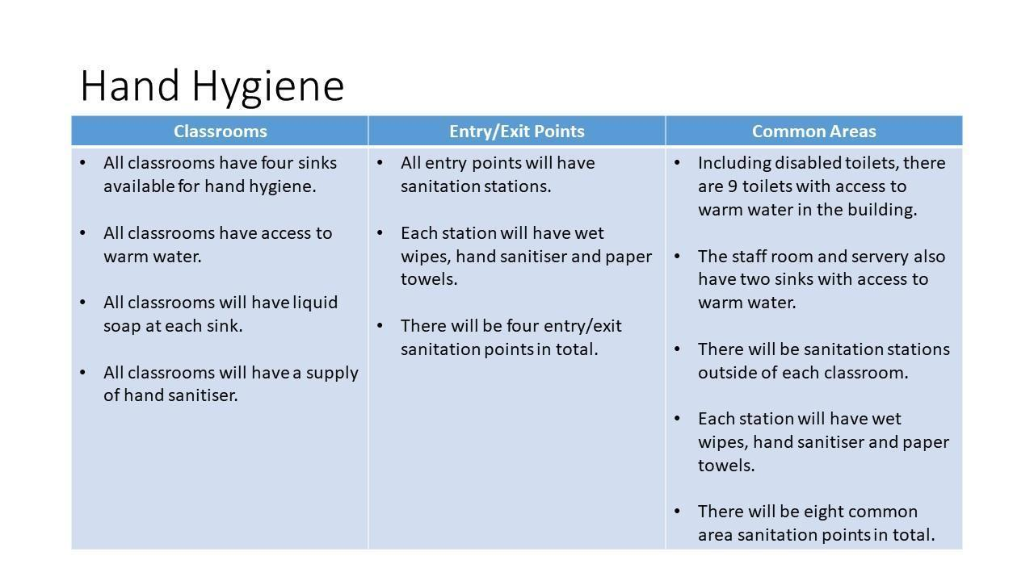
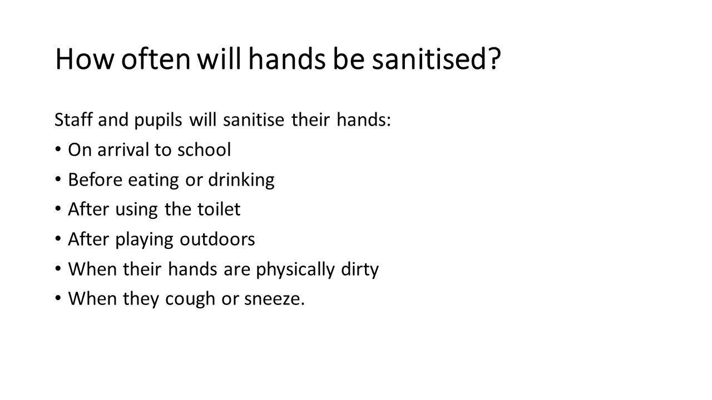
Updated February 2021
⮚ When entering and exiting vehicles
⮚ When entering and exiting school building

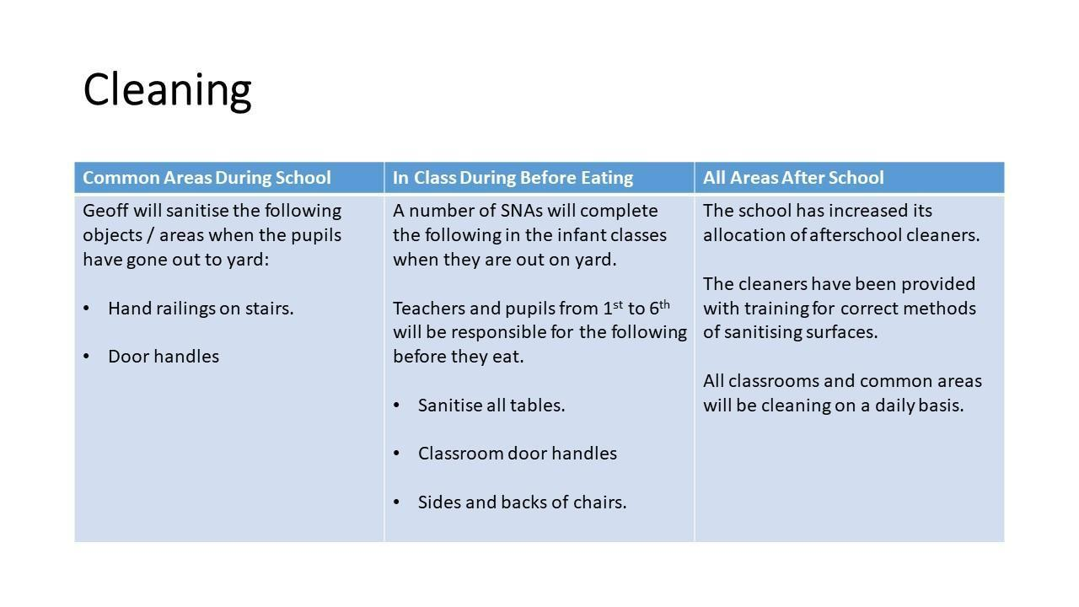
Updated February 2021 - A cleaning schedule for frequently touched surfaces will be created. This will be signed off twice a day.
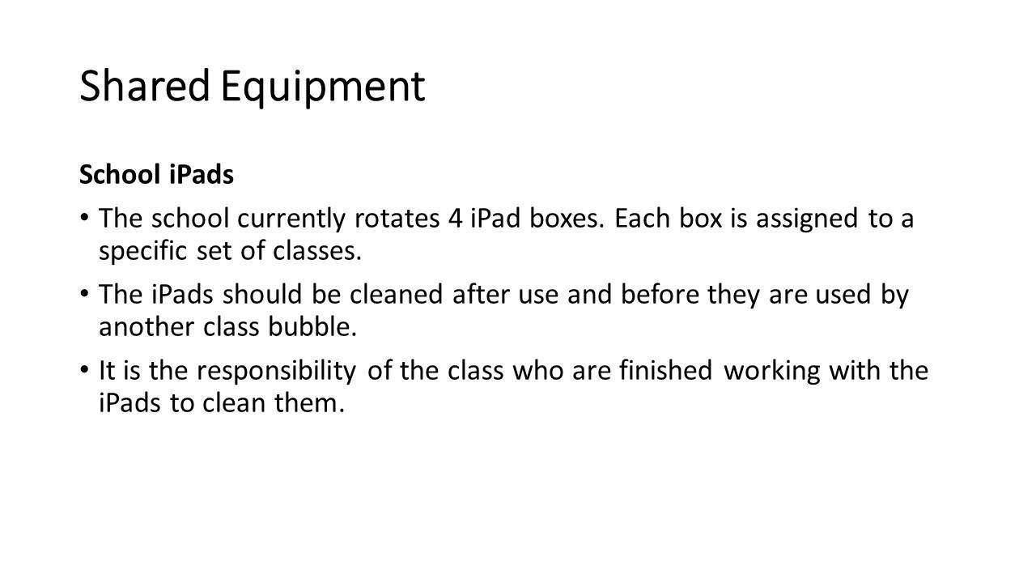
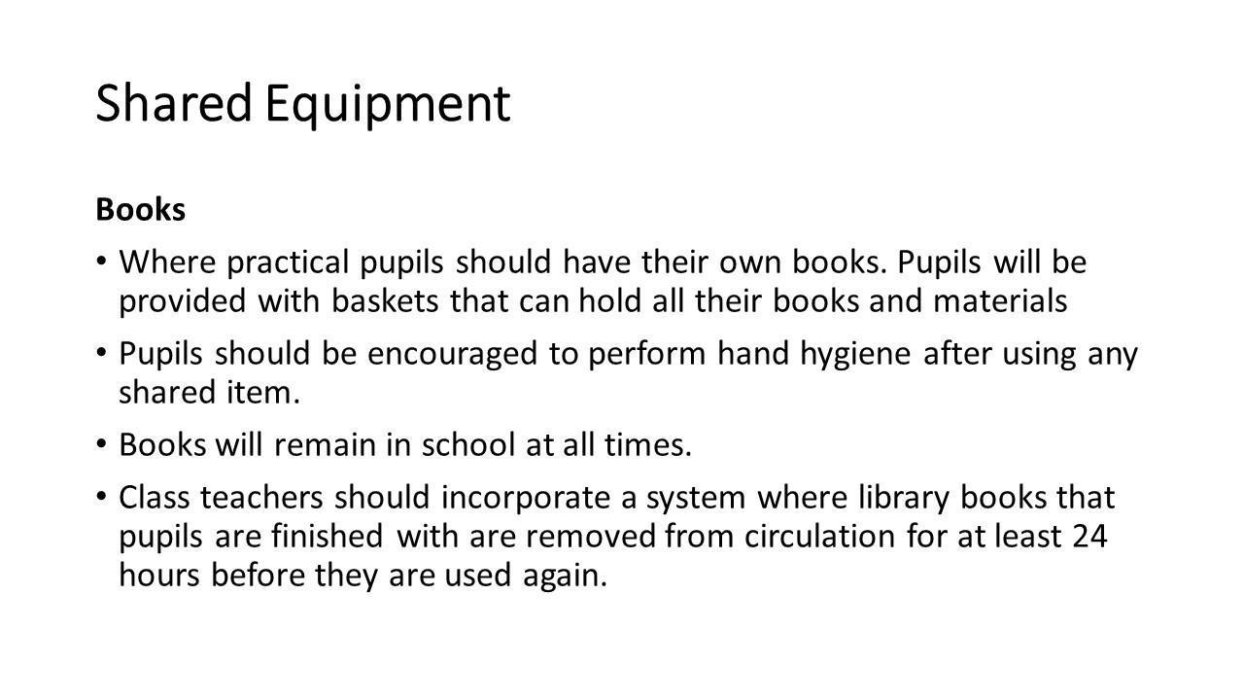
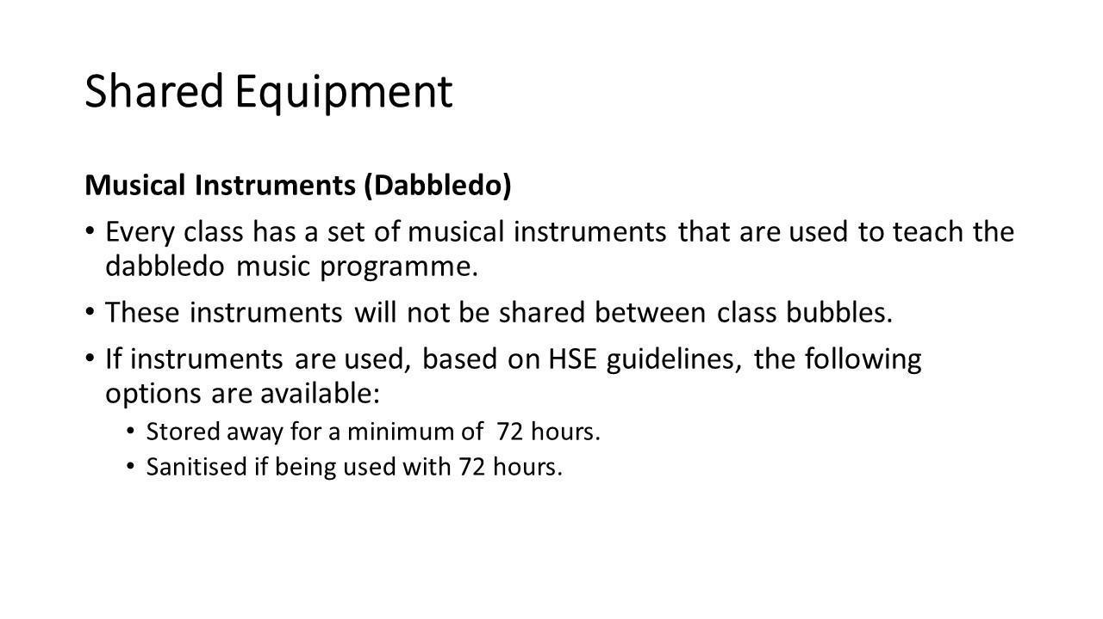
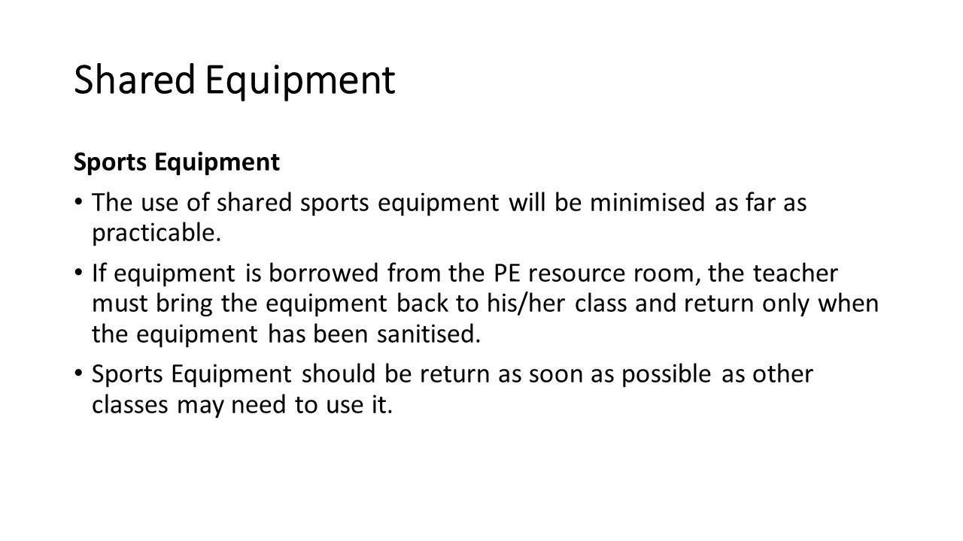
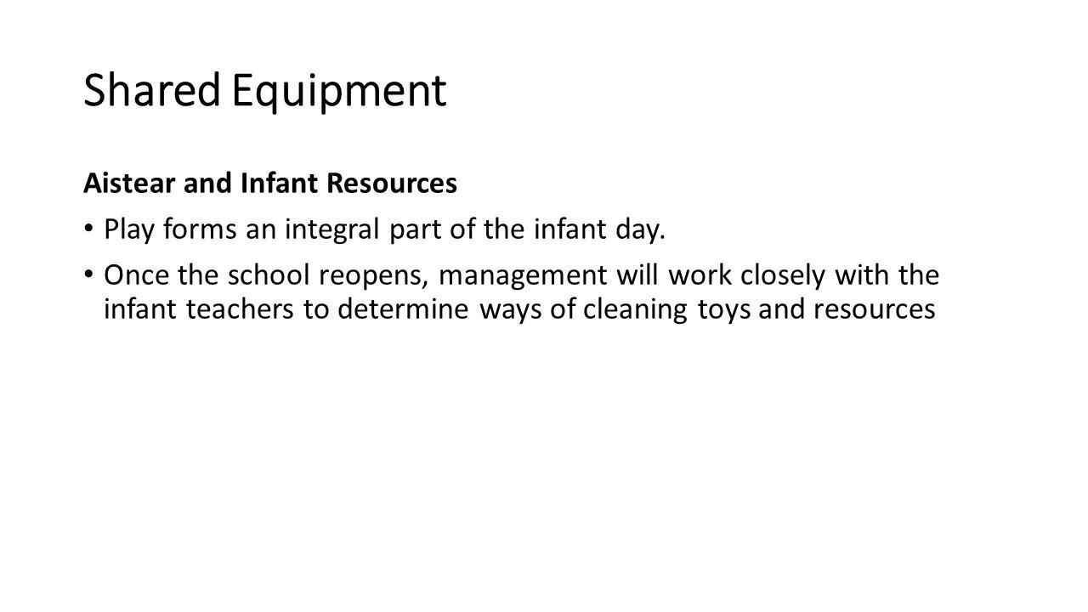

13.2. Appendix 2 – Suggested Classroom Layouts
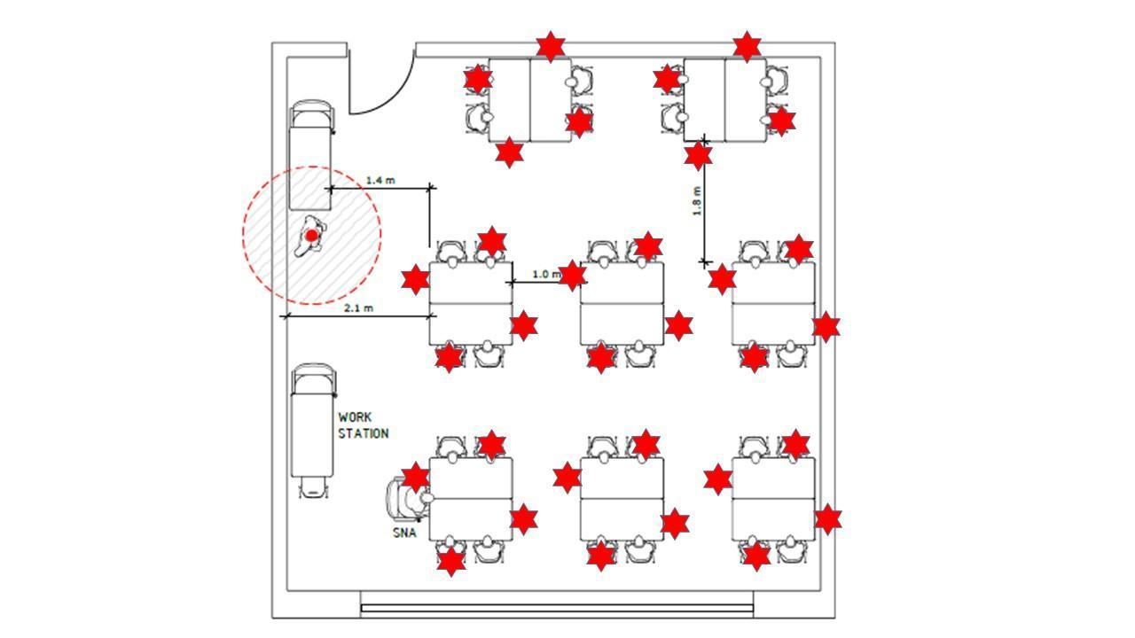
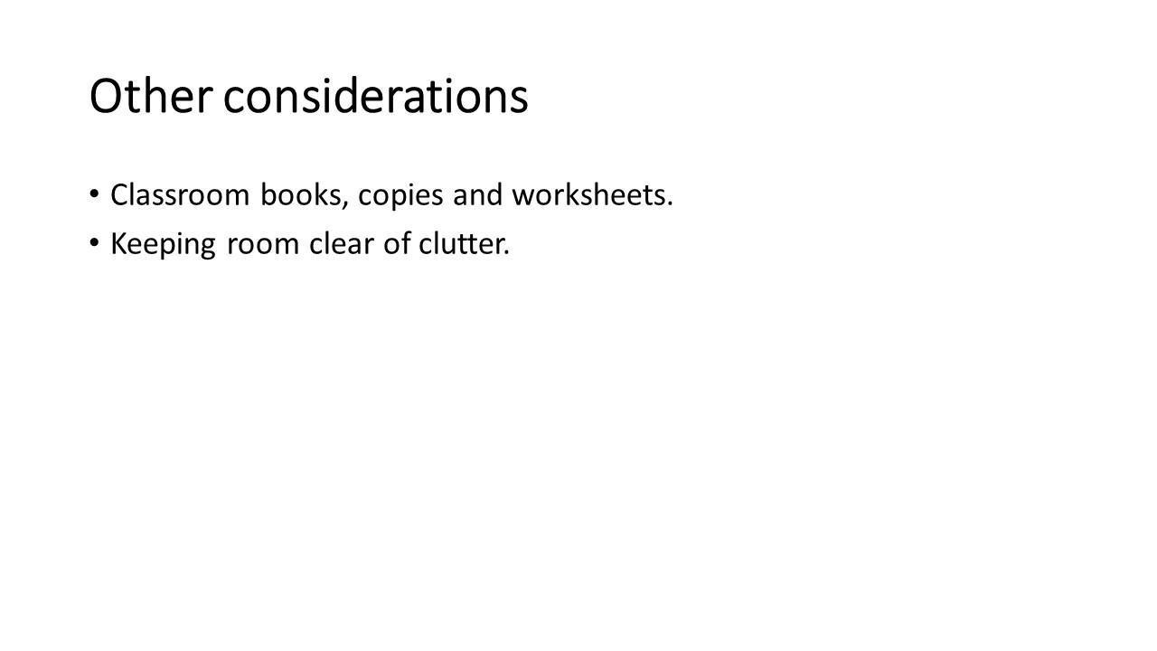

13.3. Appendix 3 – Layout of School Building
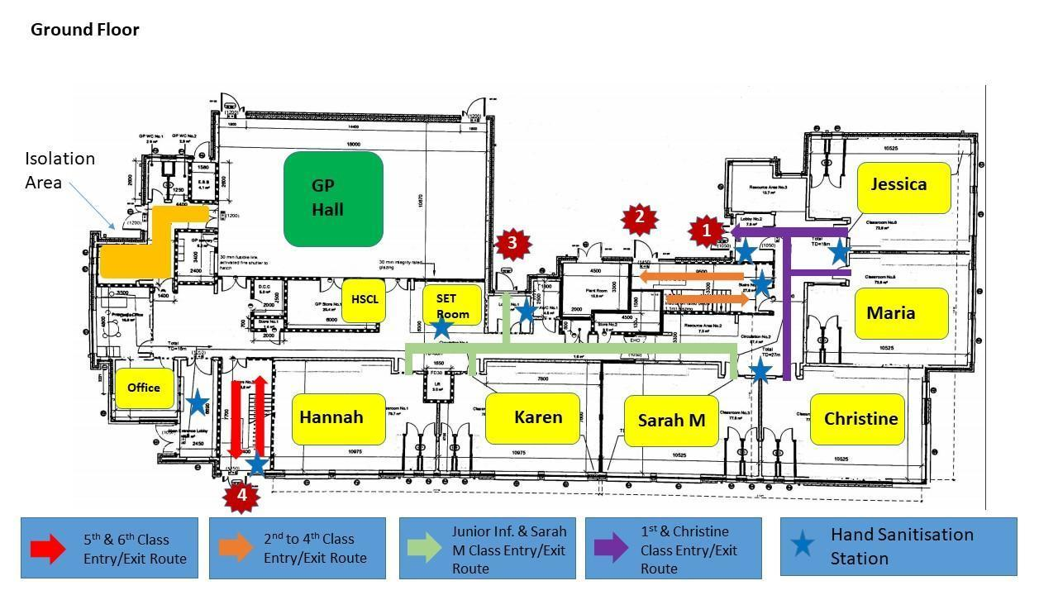
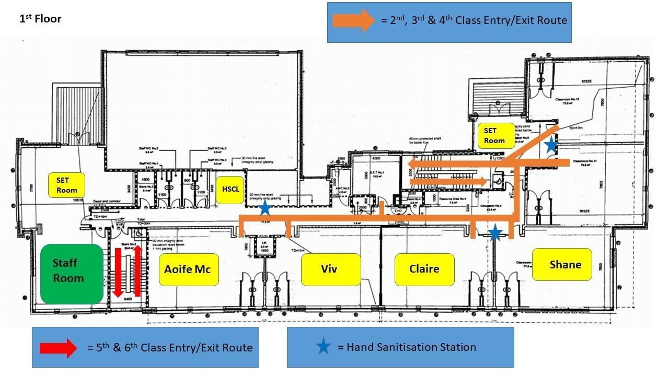
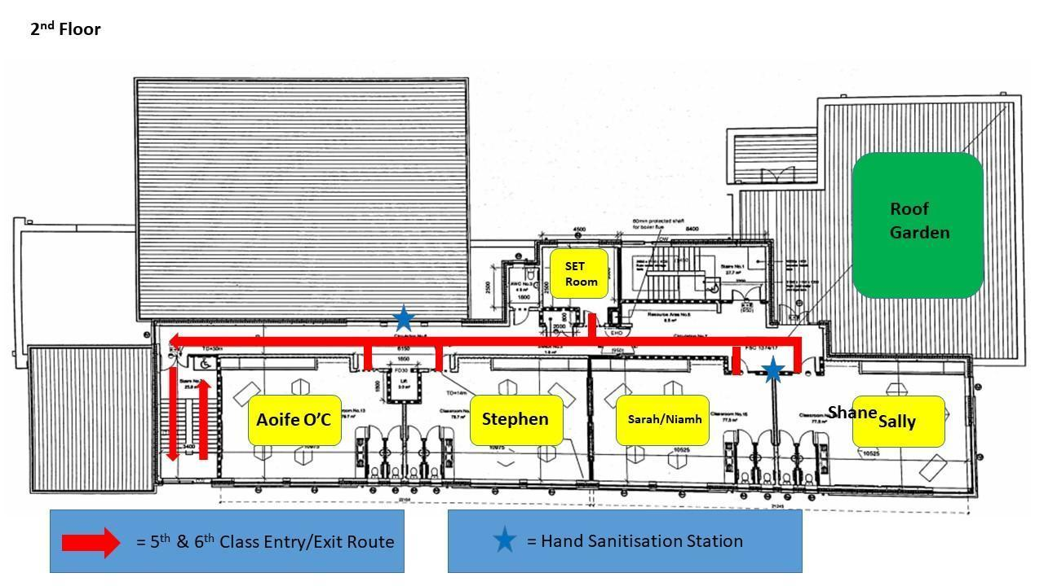

13.4. Appendix 4 – Yard Time and Supervision
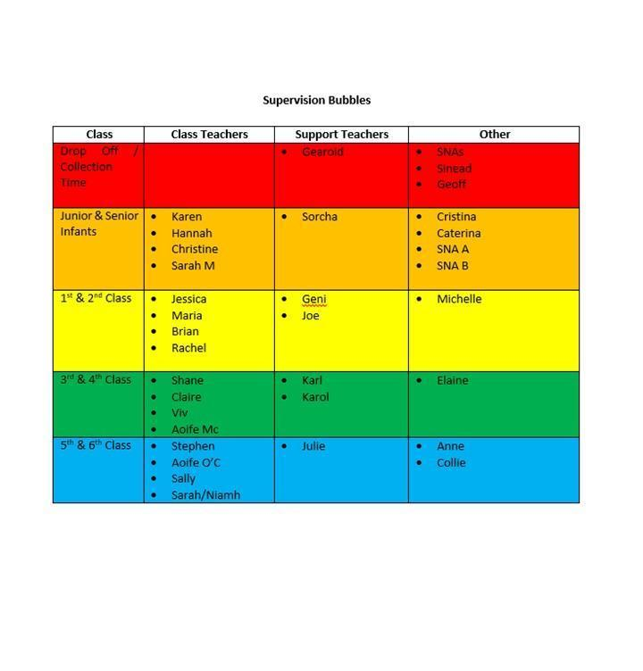
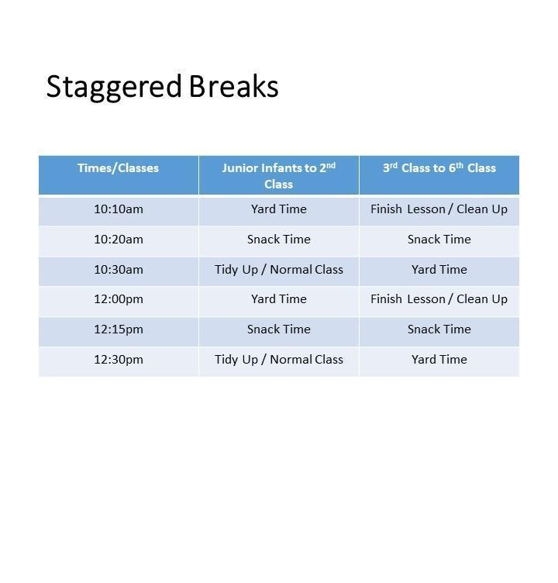
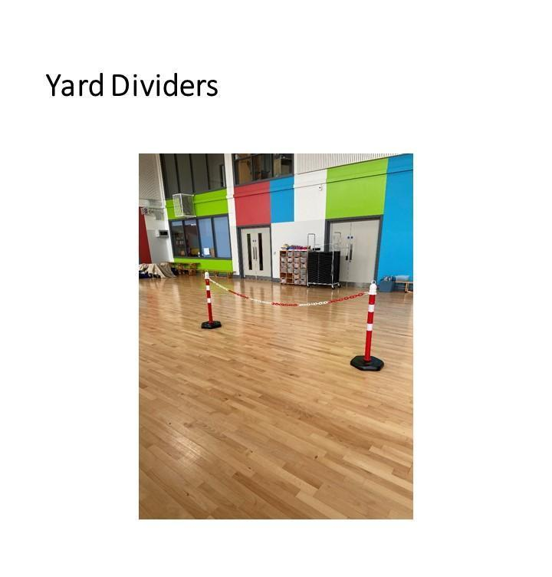
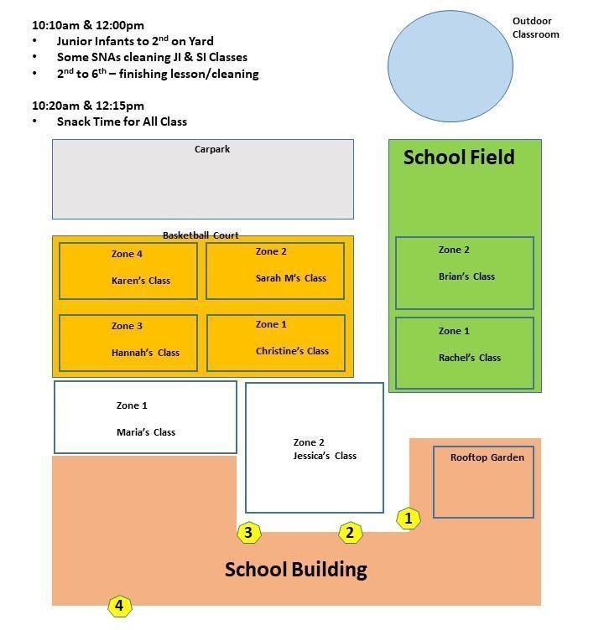
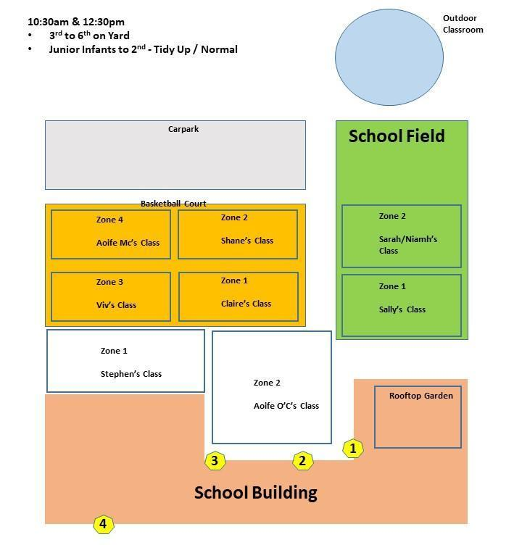

13.5. Appendix 5 – Morning Time Procedures (Coming to School)
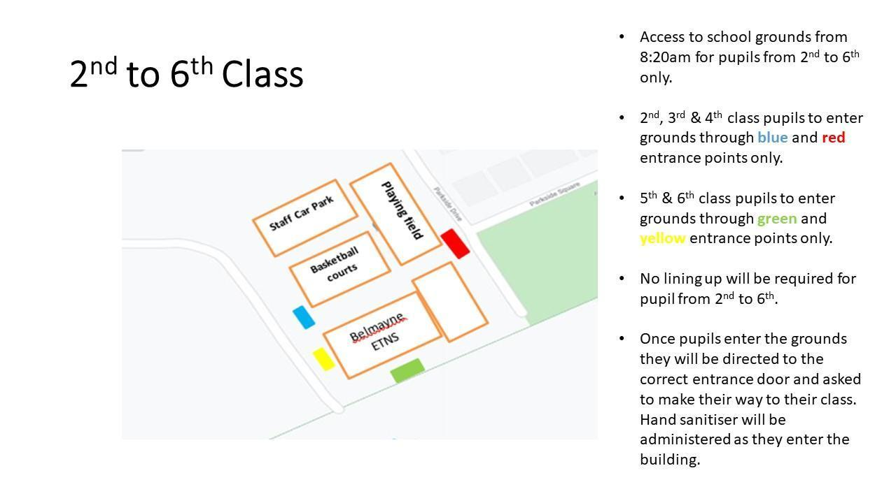
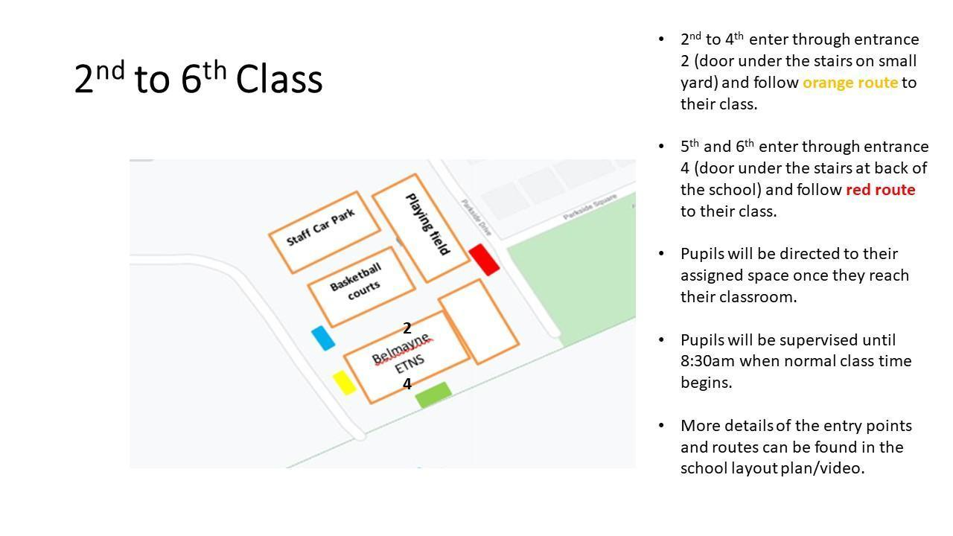
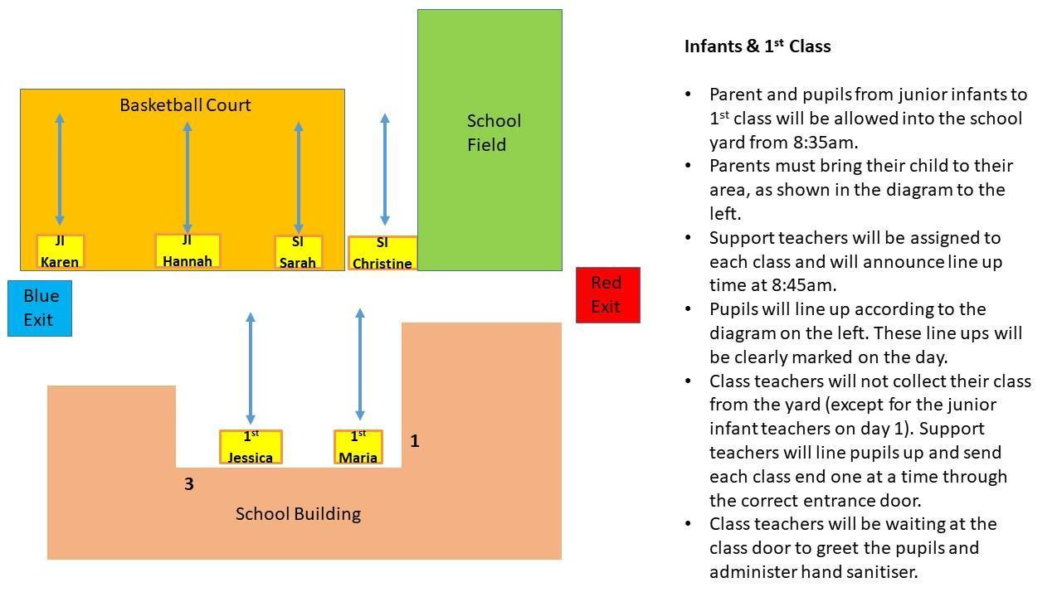
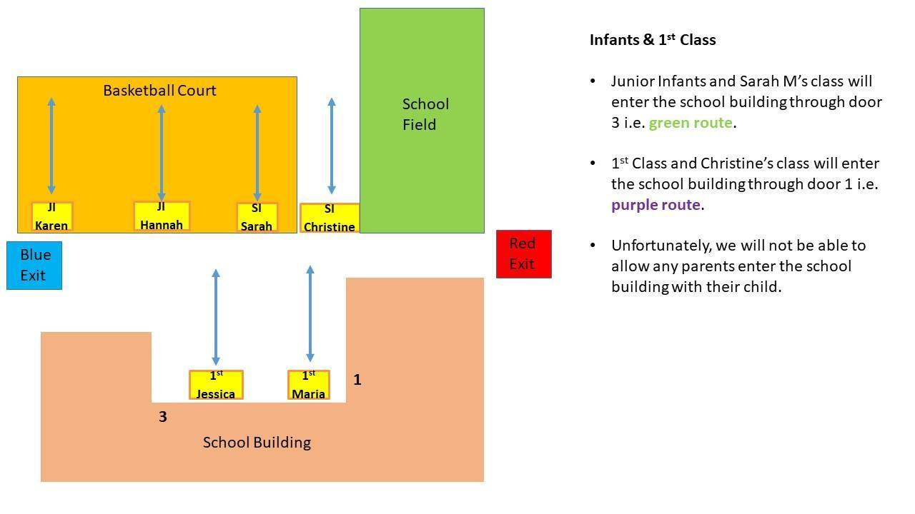

13.6. Appendix 6 – End of Day Procedures (Home Time)
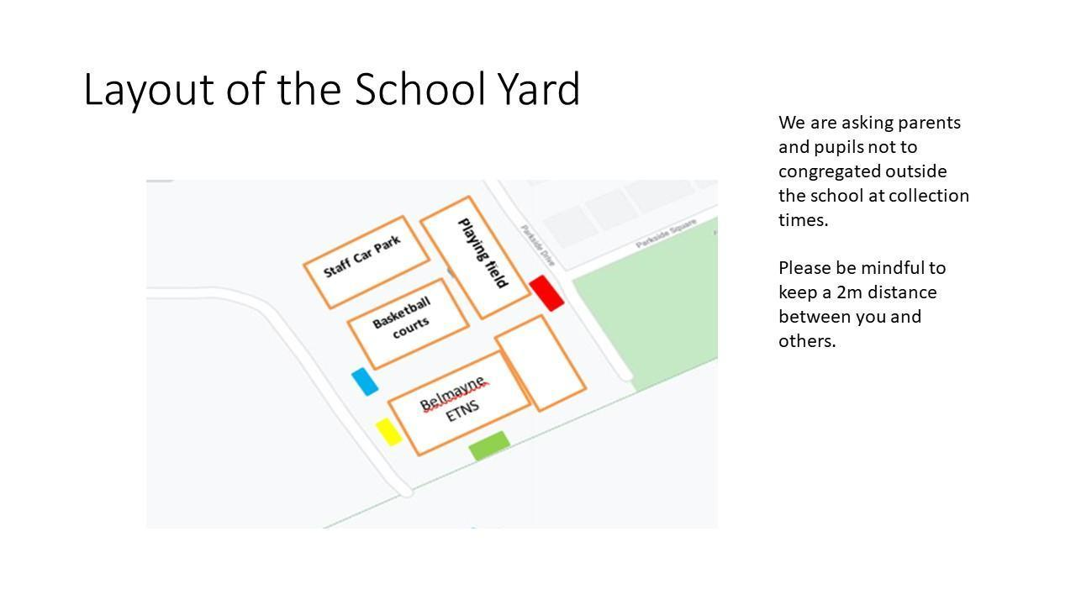
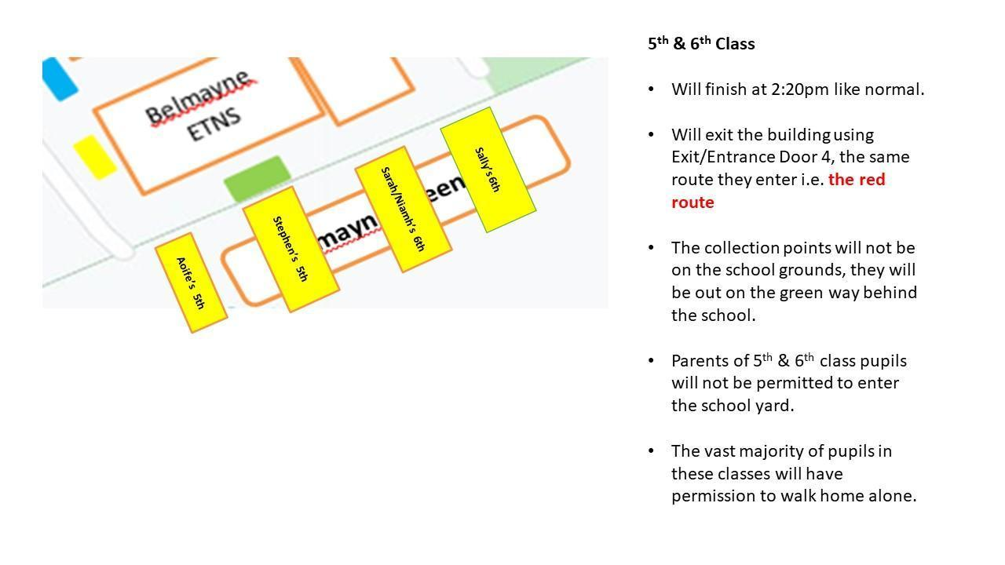
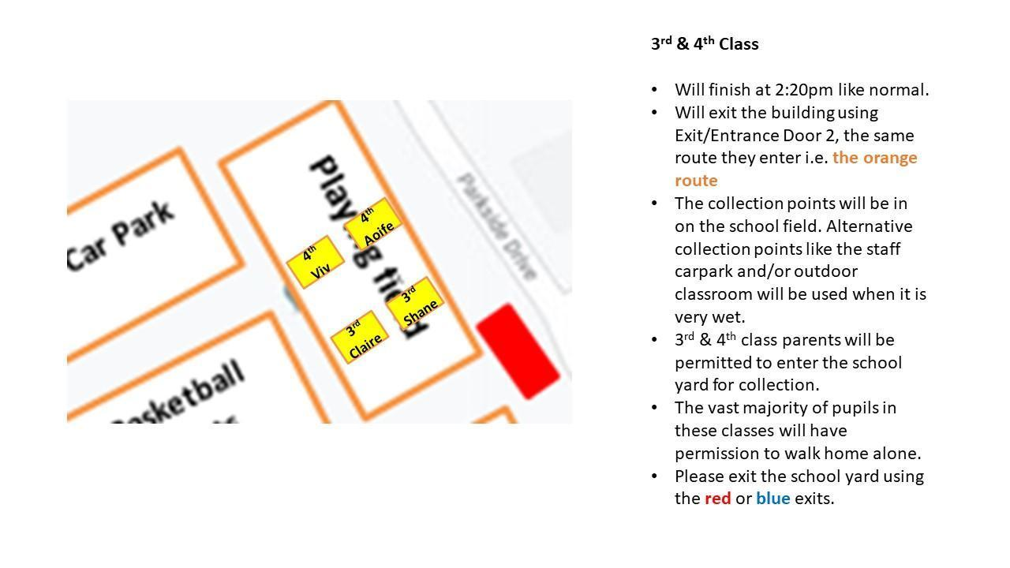
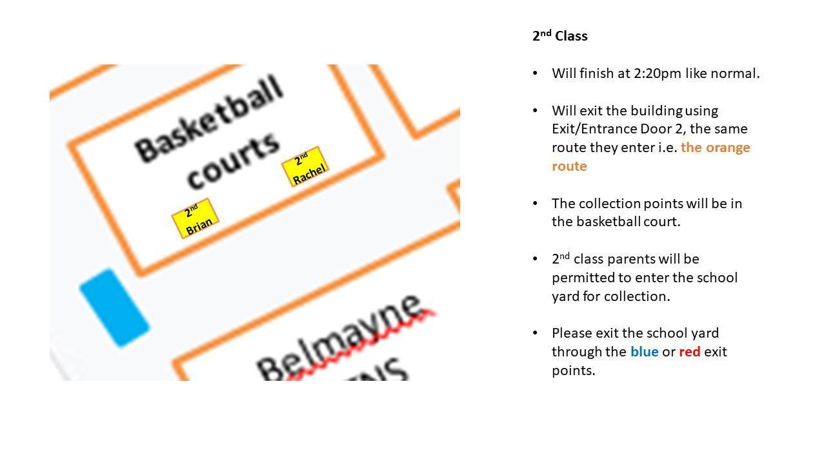
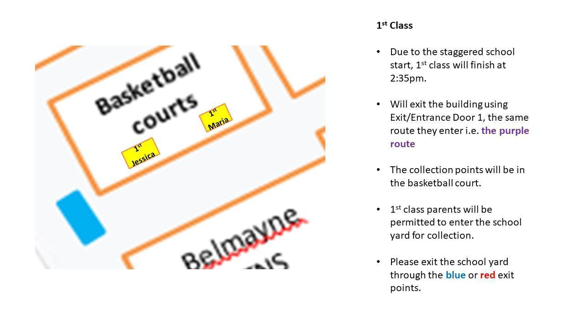
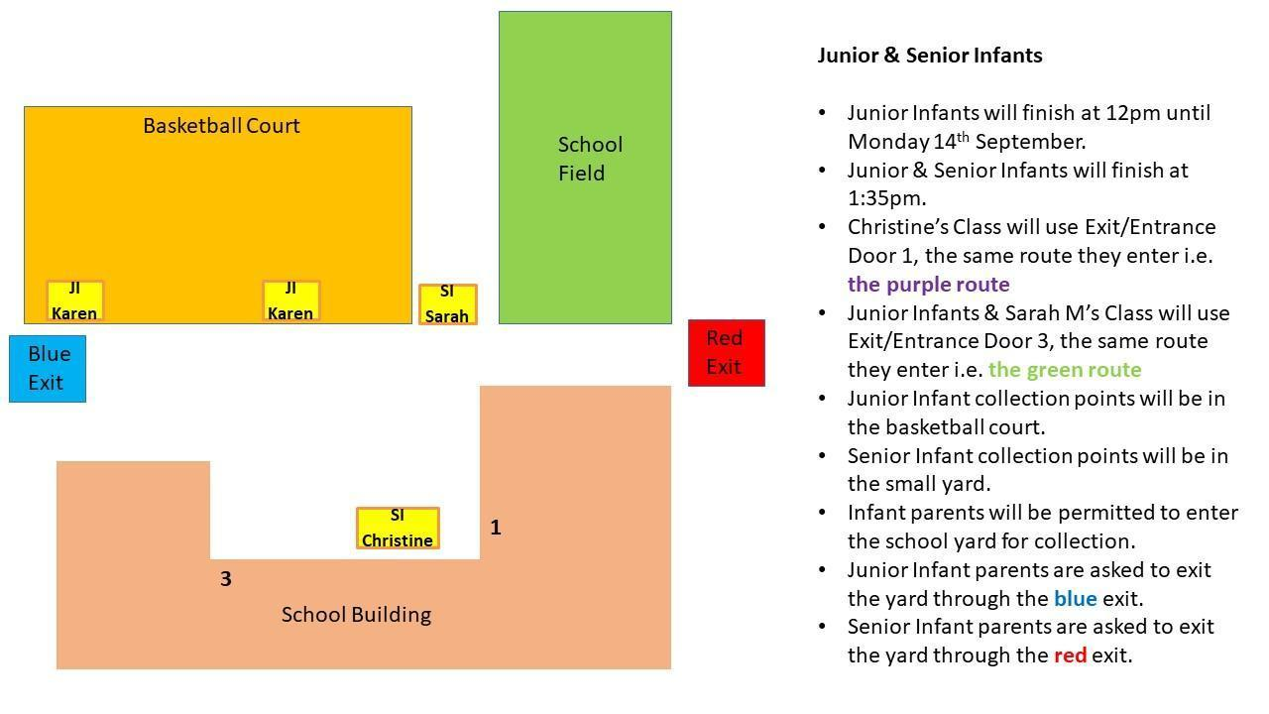

13.7. Appendix 7 – Completed Risk Assessment
Please see seperate Risk Assessment document.

